CS 255 System Design Document Tepsic

UML Diagrams

UML Use Case Diagram
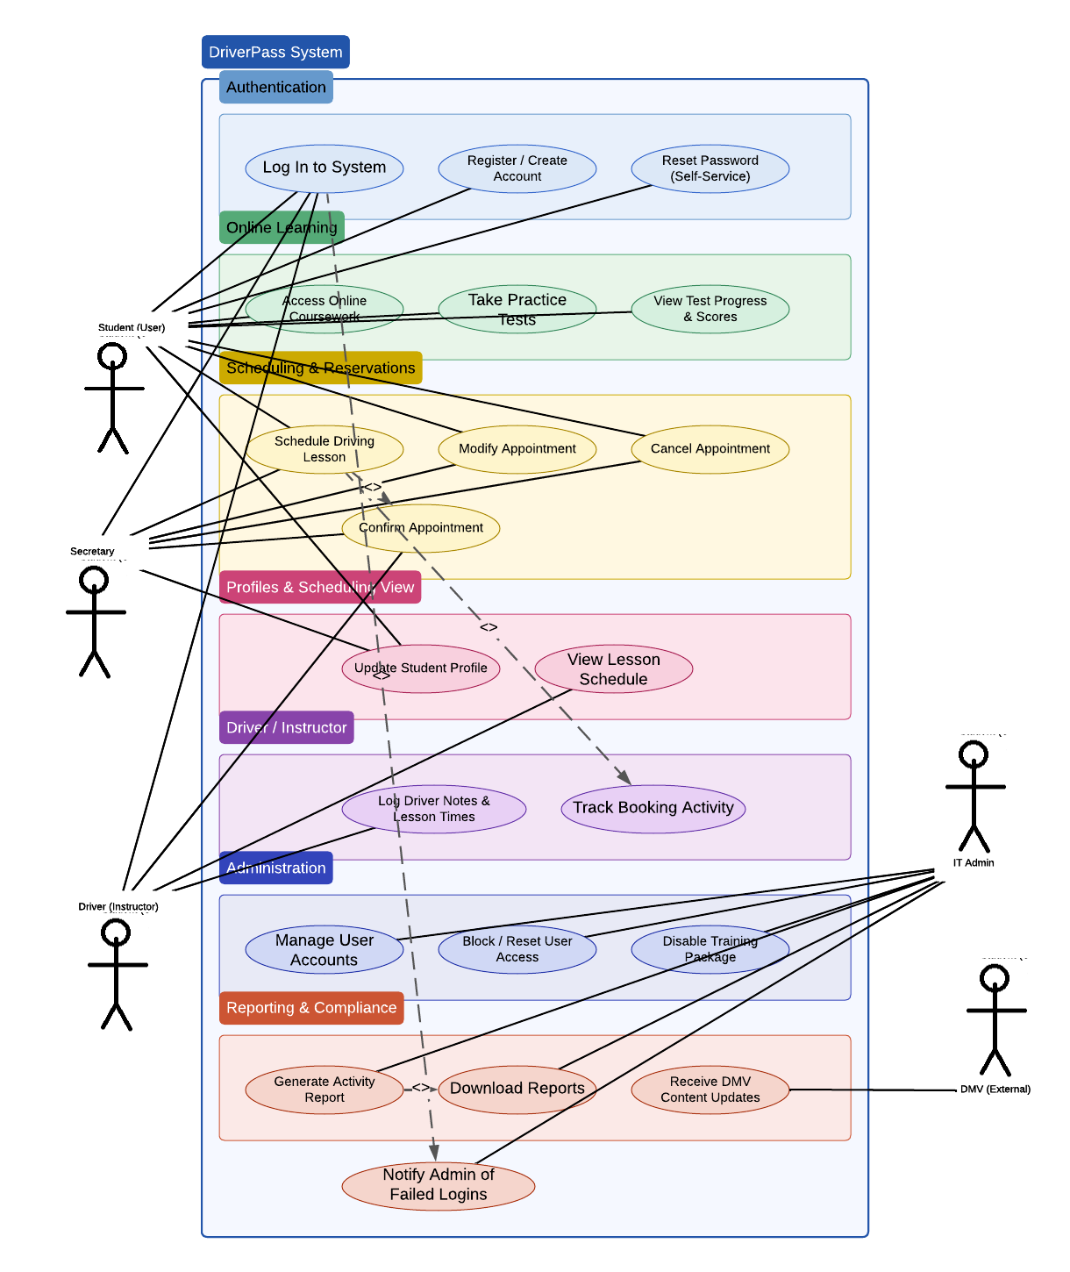

UML Activity Diagrams

Schedule Lesson Log In
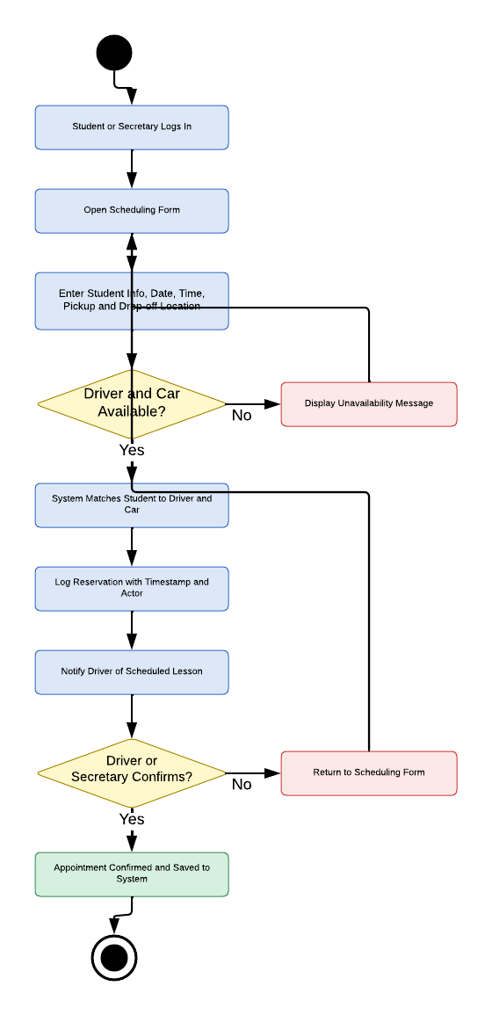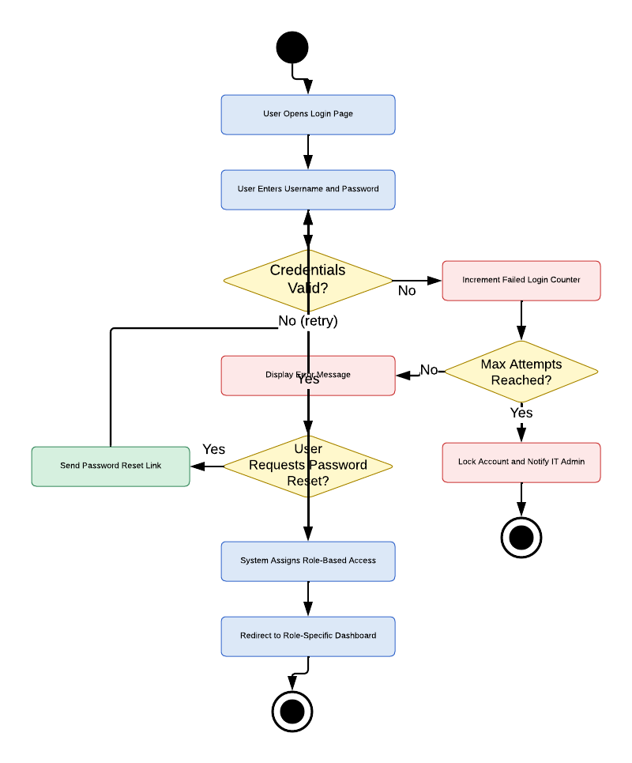

UML Sequence Diagram
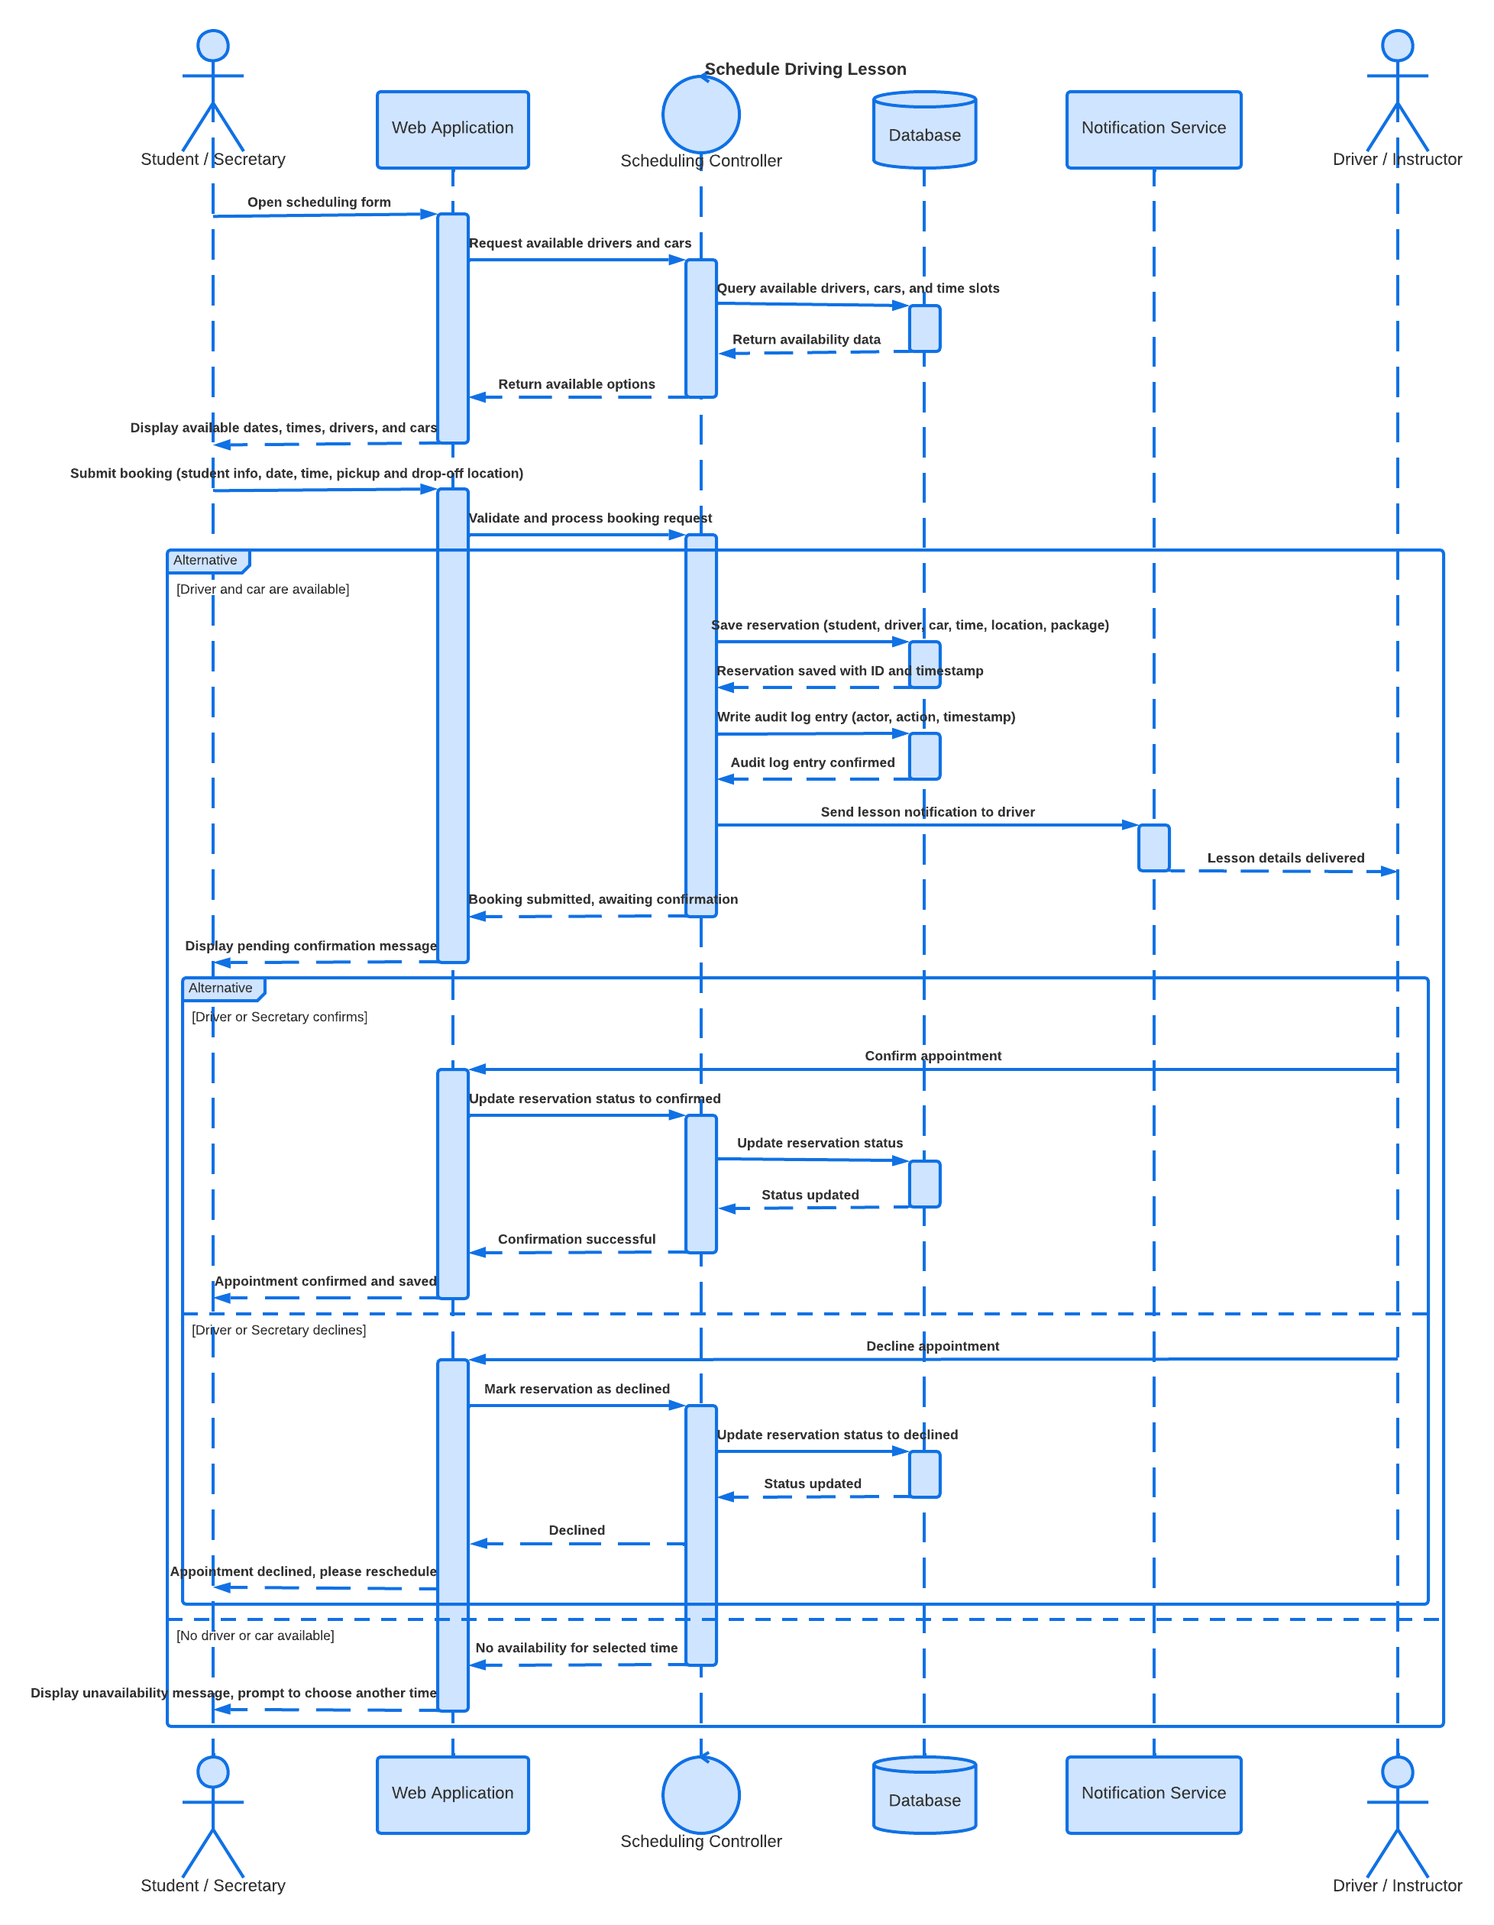

UML Class Diagram
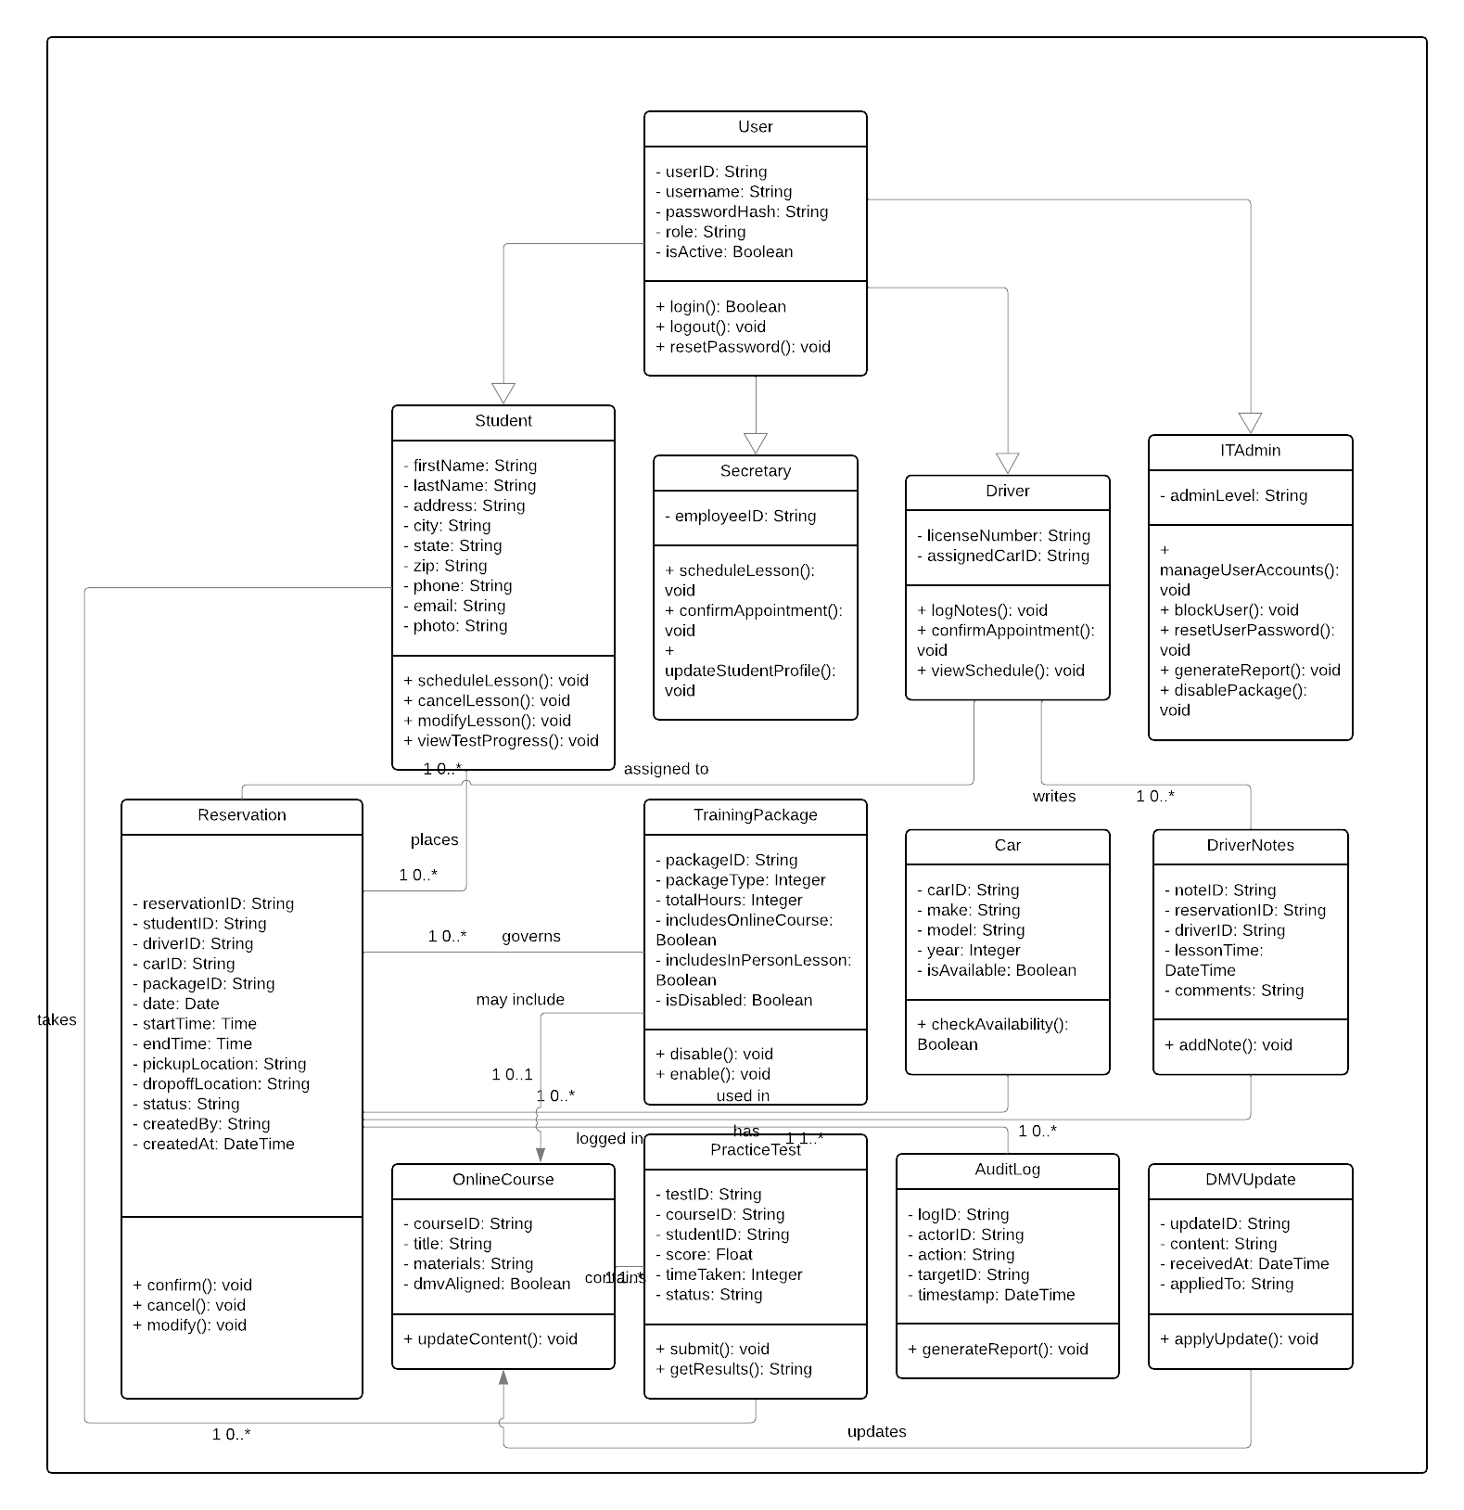

Technical Requirements
Hardware Requirements
Client Hardware
- The system must be accessible on any device that supports a modern web browser, including desktops, laptops, tablets, and mobile phones, without requiring the installation of proprietary software or hardware.

Server-Side Hardware
- The system must be hosted on a managed cloud platform, so that DriverPass does not need to maintain any on-site server hardware.
- The cloud infrastructure must ensure that the system remains available in the event of hardware failure.
- The system must support a minimum of 10 active car and driver records to reflect DriverPass's current fleet size, with the ability to scale as the business grows.

Software Requirements
Web Application
- The system must provide a browser-based web application that does not require any software installation and renders correctly across all major browsers and screen sizes.
- The system must display a role-specific dashboard for each user type so that students, secretaries, drivers, and IT admins only see the interface elements and data relevant to their role.
- The student-facing interface must display online test progress, practice test scores and statuses, driver notes, lesson times, and student profile information, consistent with the layout described in the client interview.

Back-End Application Server
- The system must include a server-side application layer that handles all business logic, including scheduling, role enforcement, credential validation, failed login tracking, account lockout, and driver notification.
- The system must include a scheduling controller that matches students to available drivers and cars, enforces two-hour session blocks, and records the student's pickup and drop-off location for each reservation.
- The system must enforce role-based access control at the server level for all routes and data endpoints, ensuring that users cannot access data or functionality outside of their assigned role even if they attempt to bypass the interface.

Database
- The system must use a database to store and manage all structured data, including user accounts, reservations, training packages, cars, online courses, practice tests, audit logs, driver notes, and DMV updates.
- The database must support all relationships defined in the class diagram, including one-to-many relationships between students and reservations, reservations and audit log entries, and online courses and practice tests.
- The system must allow data to be viewed offline through downloaded or cached exports, but must require an active internet connection for any write operations, in order to prevent data redundancy across servers.

Authentication and Session Management
- The system must validate user credentials using case-sensitive username and password matching, with passwords stored using a secure hashing algorithm.
- The system must track the number of failed login attempts per user account and automatically lock the account after a limit is reached, then send a notification to the IT Admin.
- The system must have a method for users to reset their own password so that users can regain access without contacting IT Admin.
- The system must assign a role-based session to the user upon successful login and redirect them to their role-specific dashboard.

Notification Service
- The system must integrate with an email or SMS notification service to automatically deliver lesson details to drivers when a reservation is confirmed.
- The system must send password reset links and account lockout alerts via email to ensure timely communication with users and IT Admin.

Online Learning and Testing Module
- The system must host DMV-aligned course materials and practice tests that are accessible to students enrolled in Package 3.
- The system must track each student's practice test status as one of the following: Not Taken, In Progress, Failed, or Passed, and must record the score and time taken for each attempt.
- The system must allow course content to be updated when a DMV rule, policy, or practice test change is received, so that all training materials remain current with DMV standards.

Reporting and Export
- The system must generate a printable activity report that logs every user action, including who performed the action, what the action was, what it affected, and when it occurred.
- The system must allow IT Admin and the owner to download reports and data, so that data can be reviewed and analyzed offline.
- The system must maintain audit log records as append-only entries that cannot be edited or deleted, ensuring the integrity of all activity tracking data.

Security Requirements
- The system must encrypt all data transmitted between the client and server using HTTPS and TLS to protect user data in transit.
- The system must enforce role-based access control server-side so that no user can access data, pages, or functionality outside of their assigned role.
- The system must notify the IT Admin by email whenever a user account is locked due to repeated failed login attempts so that the admin can take appropriate action.
- The system must allow IT Admin to reset or block any user account at any time without requiring developer involvement, in order to support employee offboarding and access management.

Infrastructure and Integration Requirements
Cloud Infrastructure
- The cloud platform must perform automated daily backups and provide disaster recovery capabilities so that DriverPass data is never permanently lost due to system failure.
- The system must be configured with auto-scaling so that performance and availability are maintained during periods of peak usage across all user types simultaneously.

DMV Integration
- The system must maintain a connection with the DMV so that it can receive automatic notifications whenever DMV rules, policies, or practice test content are updated.
- The system must apply received DMV updates to the online course content automatically so that students always have access to the most current training materials without manual intervention.

